Running the Group
South Wilts Ramblers’ committee met on Tuesday 19 September at the Royal George in Bedwin Street. The whole committee is up for election at the forthcoming AGM on November 28th in Bishopstone and although most are up for re-election, Anne, Ian and Bernie are standing down. We therefore need a new Chair, and at least one, preferably three committee members plus someone to take on Ian’s job of planning the midweek walks programme. Finding a replacement for Ian is vitally important if we are to continue offering a variety of walks on weekdays. We would also like to take some of the load off the Chair by finding a PR/Media person whose remit would include editing the Newsletter.

Something we all agreed on was our rather lackadaisical attitude to carrying emergency information on walks – what it’s essential to know (ID, medication etc), and who to contact should anyone experience an accident or become unconscious. Jennifer issues all new members with an ID card to be completed and taken on all walks. Sports and outdoor activities routinely require participants to do this and walk leaders should insist on it at the start of a walk.

Other items discussed included plans for the AGM, the Walk Manager system and equipment for our footpath work. (See our website for Minutes)

NEW MIDWEEK WALK PROGRAMMER URGENTLY NEEDED
After 9 years on the committee, I am standing down at this year’s AGM. I am happy to continue doing the Midweek Walks Programme but unfortunately, I am not allowed to once I cease to be a member of the committee, according to the South Wiltshire Group Constitution.

I am happy to buddy up with somebody else who is interested in taking on the role and hence joining the committee.

The job includes:
Attending four committee meetings a year plus the AGM.
Planning a monthly rolling programme, 2 months in advance to give leaders time to recce their planned walks. This is done by several emails until all the slots are filled.
Entering walks on to Walk Manager when templates come back from the walk leaders.
I have my own four-monthly template with the available dates for each month. I then enter a walk leader against the date after an offer of a walk is received. I also mark it when the completed template is received, and the walk entered on Walk Manager. The last thing I enter is when I receive the Risk Assessment for that walk. The use of this template enables me to keep tabs on the progress of each walk and allows me to chase up walk leaders if necessary.
I also keep a rolling spreadsheet with the details of each walk to make sure we don’t have walks in the same area close together.
There can be up to 15 walks each month to fill. Some short and some long. Where there is a long walk (8+ miles) I usually manage to get a short walk on the same day to give walkers a choice.
Dealing with any walk cancellations and finding a replacement if possible.
Risk Assessments I keep for 3 years in folders, on my PC, for each month and year. I have just deleted the folder for September 2000 so will need deleting for each month from now on.
I also request walk numbers from each leader which assists me in submitting the 3 monthly reports to committee and the AGM.
Flagging up problems with walk manager and the Ramblers App to the Ramblers Help Desk.
Managing the walk leaders contact list and remove or add leaders as required.
Ian Beaver

As Chair of the Group, I would just add our appreciation for everything Ian has done, particularly during and after the covid lock-downs, then building up the numbers of midweek walk leaders and, most recently grappling with the Ramblers’ new Walks Manager programme. Thank you, Ian.
Anne

GROUP FINANCES
The Financial Year for Ramblers runs from 1 October to 30 September. As Group Treasurer, I am currently compiling the Annual Return which will be finalised at the end of the month and sent to Area in October. Each year we automatically receive funding based on the number of members in our group. In addition, we can request funds for specific walks related items and activities. Our Path Clearance & Heavy Gang teams have a wish list of equipment and tools, together with training and Personal Protective Equipment needed in order that we can safely operate the equipment. Our popular walks booklets are, in essence, self-financing. The income from sales that we make is then invested into printing of new booklets.
Carolyn Bouckley
Treasurer

Memorial walk for Ted Eagle
A year ago we put up a plaque to commemorate the 100th birthday of our oldest member, Ted Eagle and it was with great sadness that we heard of his death in May this year. He died peacefully in his sleep at Salisbury Hospital and a private woodland burial took place at Cholderton.

On Wednesday 5th July, Ray Gipson organised a memorial walk to commemorate Ted, whose daughters Suzanne and Jennifer joined 20 South Wilts Ramblers on a walk from Salisbury through Stratford-sub-castle, passing Ted’s plaque. Ray said a few words, everyone went to the nearby pub for drinks and lunch afterwards and all agreed it had been a thoroughly worthwhile event. Ted would have loved it. Many thanks to Ray for organising, and personal regrets from those of us unable to be there.

Ted’s daughters sent the following message:

Thank you so much Ray for organising the walk on Wednesday, it was very heart- warming to hear such lovely comments from everyone. Please reiterate our thanks & pleasure when you see people next, I wasn't really prepared to say anything so rather caught off guard! Dad would have been surprised & honoured to know he was commemorated in this way.
Walkers are such good company!
Thanks again.

With very best wishes from
Suzanne & Jennifer

SHelagh’s Birthday Walk with fly past


‘There are days when all the stars align and the 3rd September was such a day, 25 Ramblers, including 4 guests from East Dorset, gathered in Studland to celebrate Shelagh’s special birthday, wonderful sunshine graced the day, the outstanding walk, very ably led by Phil Hutchins, included heathland to start with and then the spectacular views of the Dorset coastline, heading down to Old Harry’s Rock when we were treated to an unbelievable fly past by the Red Arrows who were demonstrating at the Bournemouth Air Show.
The splendid day was rounded off with top quality wine supplied by Kevin and home made cakes courtesy of Liz, Rose and Jennifer, plus a few prezzies for the birthday girl - a truly fabulous day for a very special lady  this is the joy of South Wilts Ramblers’
Jane Owen

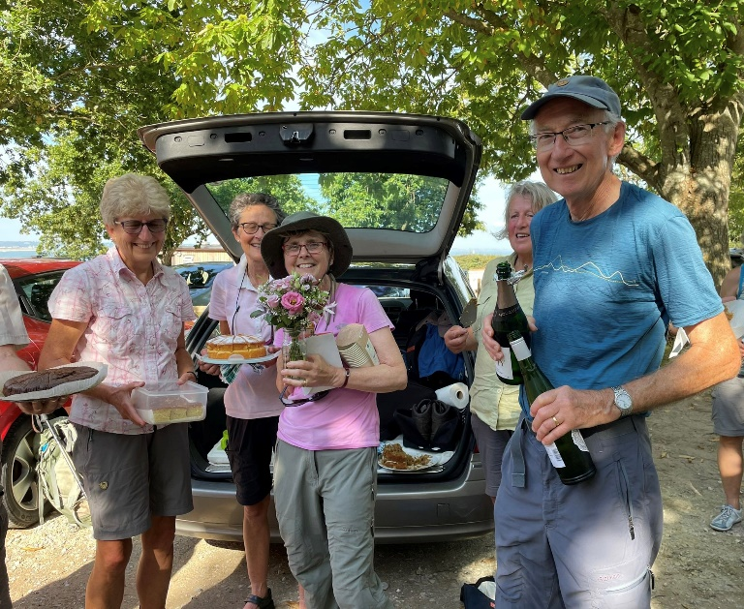

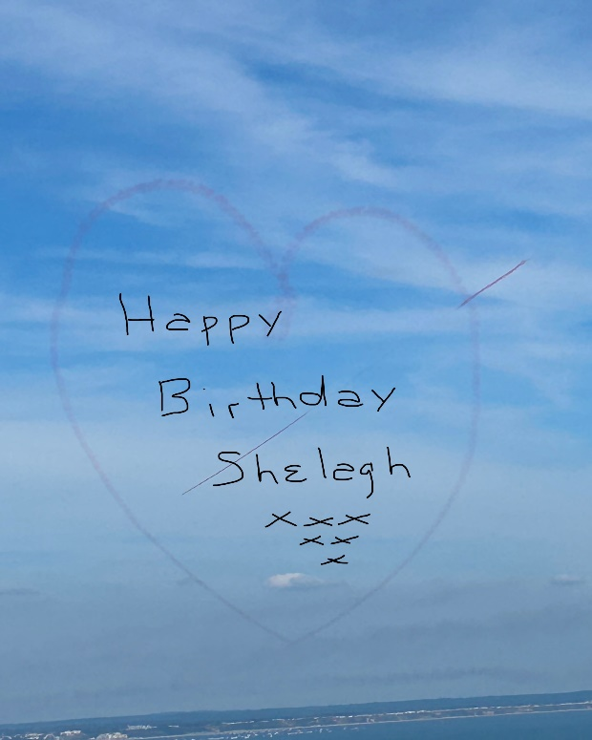

(Are there no limits to what South Wilts Ramblers will do to give members a good time? -Ed)

FOOTpaths FIT FOR WALKING
“That was the week, that was…..”
The week running up to the August holiday weekend was a busy one for South Wilts Ramblers. It started on Monday 21st when Heavy Gang assembled in Bishopstone to work alongside the River Ebble (footpath BSTO10). The tasks included replacement of a somewhat dodgy footbridge and improvements to another, but most time was spent rebuilding a stretch of the river bank. This had become undermined by the river and was almost impassable, so the edge was restored with lengths of chestnut and willow held in place by fence posts before backfilling to raise the level of the path. An unusual visitor was a large crayfish which emerged to watch proceedings – maybe disturbed by a fence post coming through the roof of its home! From its size it may have been the American invader the Signal Crayfish, which is known to erode river banks by burrowing and tunnelling.

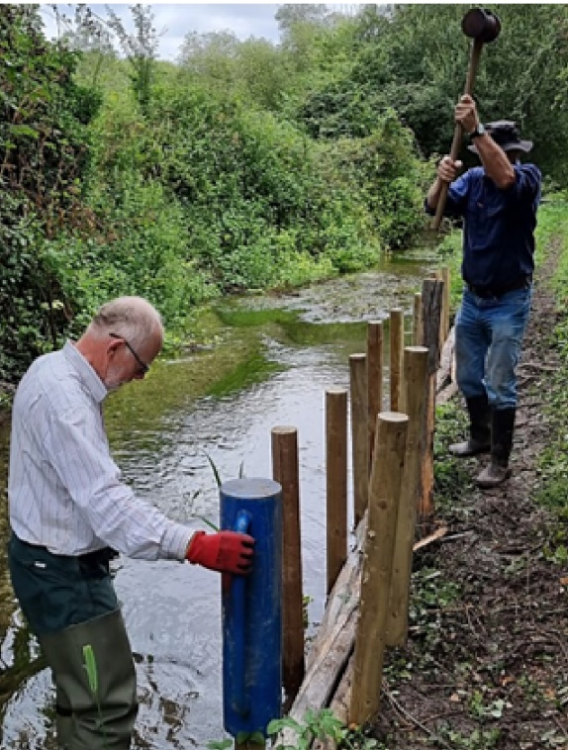

Tuesday saw one of our regular morning walks around Downton and Trafalgar House, followed by no less than three walks on Thursday: a morning walk starting from Martin Down, a longer brisk walk around the Winterbournes and Figsbury Ring, and finally an evening five mile walk followed by a pub meal.

Our evening walks have proved a popular addition to the programme and provide an opportunity for those who prefer a shorter walk but may be busy during the day. By chance our evening walk on this occasion was based around Bishopstone, which gave 17 ramblers the opportunity to stress test the work of the Heavy Gang just days earlier before adjourning to the White Hart in Bishopstone for a very enjoyable meal.

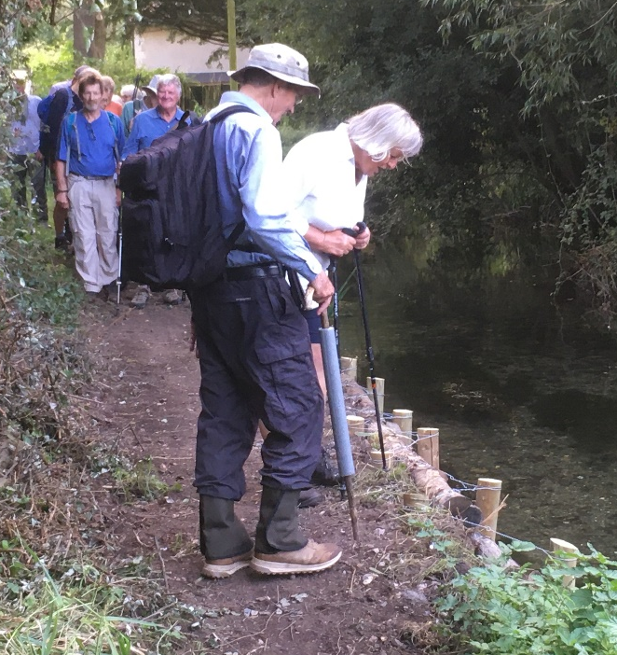

The week finished with the Sunday walk of 11 miles starting (and ending!) in Whiteparish.

The week may have been busier than most, but South Wilts Ramblers can be justifiably proud of the diversity and extent of our walk programme, and our contribution to footpath maintenance and improvement.

Charles Penn
Footpaths Officer

Condolences
We send our heartfelt condolences to long-standing member of South Wilts Ramblers, Barbara Wilmot on the sad death of her husband Harold who was also a valued member of the Group. Many of our members will attend Harold’s memorial service on 23rd September. Barbara is in our thoughts.

EMAIL CORRESPONDENCE
Jennifer (Membership Secretary) would remind you to get in touch with her jennifer@farmadmin.co.uk if you think you are not receiving her emails. Under Ramblers data protection arrangements, all communications from Group or Area to members, are sent from her.

DATES FOR YOUR DIARY
Tuesday 14 November QUIZ NIGHT South Wilts Sports/Cricket club

Tuesday 28 November GROUP AGM & TALK, Bishopstone Village Hall. Speaker: Chris Waller, South Wilts Rambler and Orthopaedic Surgeon

Tuesday 5 December SOUTH WILTS COMMITTEE Meeting at The Royal George, Bedwin Street, Salisbury at 7.30

Finally
If you know of Group members who don’t go on-line, please could you print out a copy of this Newsletter for them?

The Winter Newsletter will go out in the second week of December. If members would like to write a piece, such as an account of a good walk (preferably with a photo), please contact the new Chair.

